# Restrict data input by using a validation rule

| **Expressions for Numbers** | | |
| --- | --- | --- |
| **Comparison** | **Sample Expression** | **Description** |
| Equal to | **=** 42 | The value must be 42. |
| Less than | **<**100 | The value must be less than 100. |
| Less than or equal to | **<=**100 | The value must be less than or equal to 100. |
| Greater than | **>** 0 | The value must be greater than 0. |
| Greater than or equal to | **>=** 0 | The value must be greater than or equal to 0. |
| Not equal to | **<>** 42 | The value can be anything except 42. |
| **Not** 42 |
| Greater than X and less than Y | >10 **and** <20 | The value must be greater than 10 and less than 20. **10 and 20 are not included.** |
| Between | **Between** 0 **and** 100 | The value must be 0, 100, or somewhere in between. |
| >=0 and <=100 |

| **Expressions for Dates and Times** | | |
| --- | --- | --- |
| **Comparison** | **Sample Expression** | **Description** |
| Less than | <#30/1/2012# | The date occurs before January 30, 2012. |
| Greater than | >#30/1/2012# | The date occurs after January 30, 2012. |
| Between | Between #1/10/2013# and #31/10/2013# | The date occurs on October 2010. |
| Greater than the current date | >Date( ) | The date occurs today or after. |
| Less than the current date | <Date( ) | The date occurs yesterday or before. |
| Greater than the current date (and time) | >Now() | The date occurs today after the current time, or any day in the future. |
| Less than the current date (and time) | <Now() | The date occurs today before the current time, or any day in the past. |
| **Note:** **You have to write Full date.** | | |

| **Expressions for Text** | | |
| --- | --- | --- |
| With text, validation lets you verify that a value **starts** with, **ends** with, or **contains** specific characters. You perform all these tasks with the **Like operator**, which compares text to a pattern. | | |
|  | **Sample Expression** | **Description** |
| **The asterisk (*)** represents (zero or more) characters. Thus, the complete expression asks Access to check that the value starts with R (or r), followed by a series of zero or more characters. | | |
| **starts with** | Like "R**\***" | The text must **start with** the letter R. |
| **ends with** | Like "**\***ed" | The text must **end with** the letters ed. |
| **Contains** | Like “**\***5**\***” | requires that number 5 appears somewhere in a text field |
| You can use **the wildcard (?)** to match a **single** character, which is handy  **if you know how long text (field Size) should be** or where a certain letter should appear | | |
| eight-character product code that ends with 0ZB | Like "**?????**0ZB" | Entry must be 8 characters and end with the characters "0ZB". |
| Five-character code that begins with A. | Like "A**????**" | Entry must be 5 characters and begin with the letter "A". |

**OR**

You can use the **or** keyword to accept a value if it meets one, two or more conditions.

>1000 Or <-1000

Like "A???????" or Like "B???????"

“A” or “B” or “C” or “D” or “E”

“Amman” or “Aqaba”

**Null** = EMPTY (Blank)

|  |  |  |
| --- | --- | --- |
| If you **must fill** in *the field* | Is **Not** Null | Same as setting the field's *Required* property, but lets you create a custom message (in the *Validation Text* property.) |

|  |  |  |
| --- | --- | --- |
| **To do this ...** | **Validation Rule for Fields** | **Explanation** |
| You must fill in *the field* | Is Not Null | Same as setting the field's *Required* property, but lets you create a custom message (in the *Validation Text* property.) |
| Positive numbers only | Is Null OR >= 0 | Positive numbers only or empty |
| No more than 100% | Between -1 And 1 | 100% is 1. Use 0 instead of -1 if negative percentages are not allowed. |
| Exactly 4 digits | Between 1000 And 9999 | For Number fields. |
| No more than 100% | Between -1 And 1 | 100% is 1. Use 0 instead of -1 if negative percentages are not allowed. |
| Not a future date | <= Date() |  |
| Email address | Like "*?@?*.?*" | Requires at least one character, @, at least one character, dot, at least one character. |
| Limit to specific choices | "M" Or "F" | It is better to use a lookup table for the list, but this may be useful for simple choices such as Male/Female. |
| IN (1, 2, 4, 8) | The **IN operator** may be simpler than several ORs. |

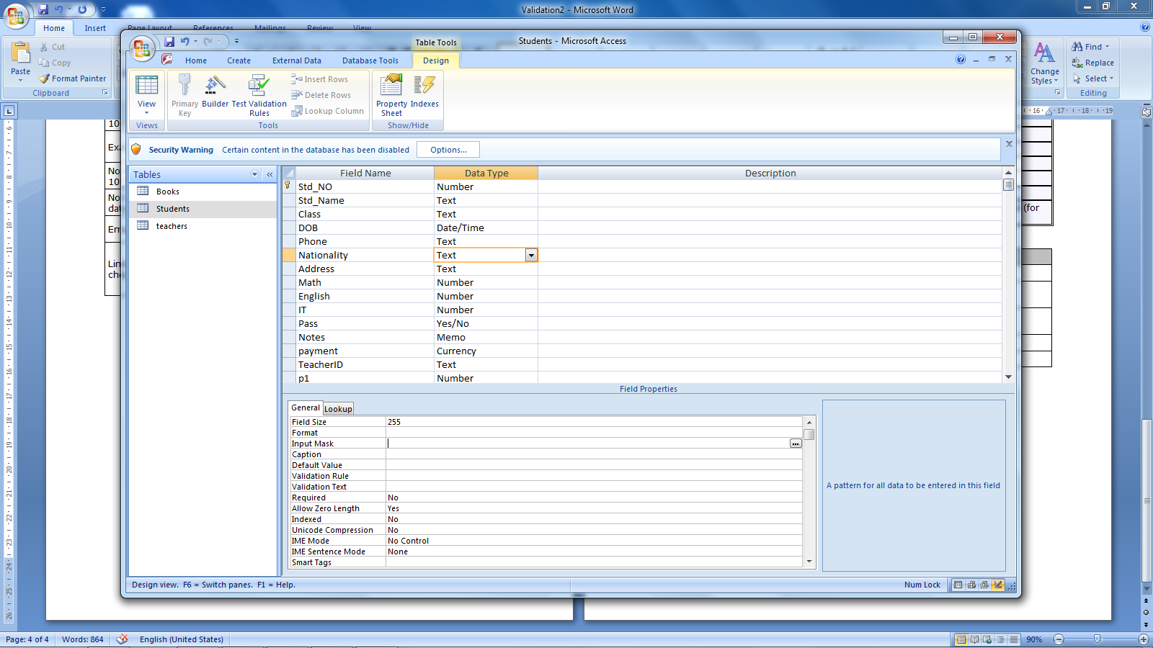

**ValidationText** :

Use the **ValidationText** property to specify a message to be displayed to the user when data is entered that violates a **ValidationRule** setting for a field.

***Input Mask***

*You can use the Input Mask property to make data entry easier and to control the values users can enter in a field.*

|  |  |
| --- | --- |
| **Character** | **Description** |
| **0** | **Digit** (0 to 9, **entry required**, plus [+] and minus [–] signs not allowed). |
| 9 | Digit or space (entry not required, plus and minus signs not allowed). |
| **L** | **Letter** (A to Z, **entry required**). |
| ? | Letter (A to Z, entry optional). |
| **A** | **Letter or digit** (**entry required**). |
| a | Letter or digit (entry optional). |
| **&** | **Any character** or a space (**entry required**). |
| C | Any character or a space (entry optional). |
| < | Causes all characters to be converted to **lowercase**. |
| > | Causes all characters to be converted to **uppercase**. |
| \ | Causes the character that follows to be displayed as the literal character (for example, \A is displayed as just A). |

|  |  |  |
| --- | --- | --- |
| **To do this ...** | **Input Mask** | **Sample Values** |
| 10 digits | 0000000000 | 4567654345 |
| 2 Letters followed by 3 digits | LL0000 | AK2345  CD1234 |
| 1 Letter followed by Dash then 2 digits | L\-00 | A-23 |
| A Phone Style | \(000") "000\-0000 | (206) 555-0248 |
| Password Field | Password | ******* |

***Note:*** *You can Use the* ***wizard button*** *to set the Input Mask or Validation Rule.*

